Spatial machine learning
Prof. Katarzyna Kopczewska
University of Warsaw, Faculty of Economic Sciences
kkopczewska@wne.uw.edu.pl
updated 15.03.2026

RF and ANN on rastered data

Spis treści
# 1. Data processing – aggregate points within rasters 1
# 2. Data processing – calculate average in neighbouring cells 6
# 3. Data processing – prepare non-empty clustered subsets 7
# 4. Artificial neural network model 9
# 5. Random Forest model 13

# 1. Data processing – aggregate points within rasters

This model is to predict if there are high-tech firms in a raster cell. Therefore we rasterise all point data and model is on raster cells.

# generate rasterised information for:
# number of firms in total # r1
# number of firms in agriculture # r2
# number of firms in service # r3
# average profitability of firms # r4
# number of big firms # r5
# number of high-tech firms # r6
# average distance to core city # r7
# average distance to closest city # r8
# number of inhabitants # r9

library(terra)

region<-region.voi # map in sf
bb<-st_bbox(region) # bounding box
bb
# xmin ymin xmax ymax
#21.61554 50.25183 24.14578 52.28784

# general raster
nrows.raster<-50 # number of rows in raster
ncols.raster<-50 # number of columns in raster

r<-rast(nrows=nrows.raster, ncols=ncols.raster, xmin=bb[1], ymin=bb[2], xmax=bb[3], ymax=bb[4]) # with terra::

plot(as.polygons(r), col=NA, border="grey70")
points(st_geometry(firms.sf), pch=".")
plot(st_geometry(region), add=TRUE)

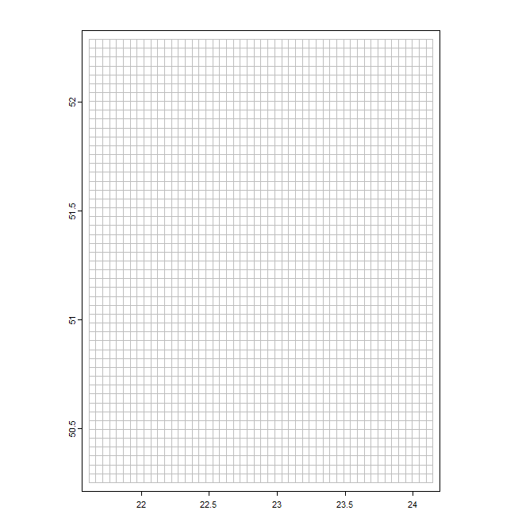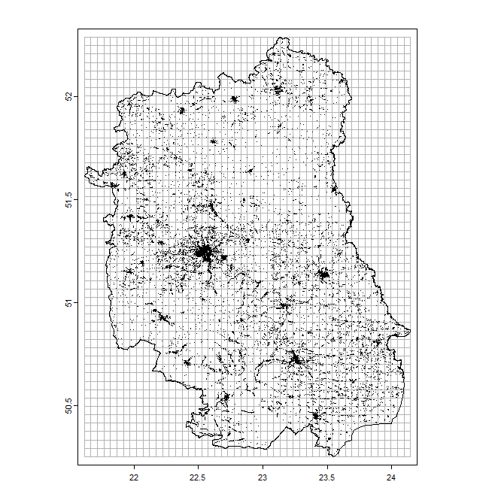

# for rasterised data – vector of ‘1’ values to easily make a sum
firms$ones<-rep(1, times=dim(firms)[1])
crds.xy<-c("new.x", "new.y")

# total number of firms
r1<-rasterize(as.matrix(firms[,crds.xy]), r, value=firms$ones, fun=sum)
plot(r1, main="Total number of firms")
plot(st_geometry(region), add=TRUE)

# total number of firms in agriculture
sub<-firms[firms$SEC_agg=="agri", ]
r2<-rasterize(as.matrix(sub[,crds.xy]), r, value=sub$ones, fun=sum)
plot(r2, main="Total number of firms in agriculture")
plot(st_geometry(region), add=TRUE)

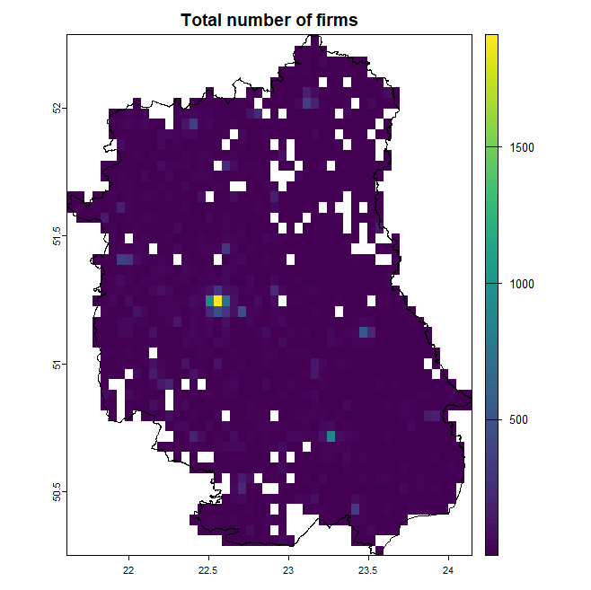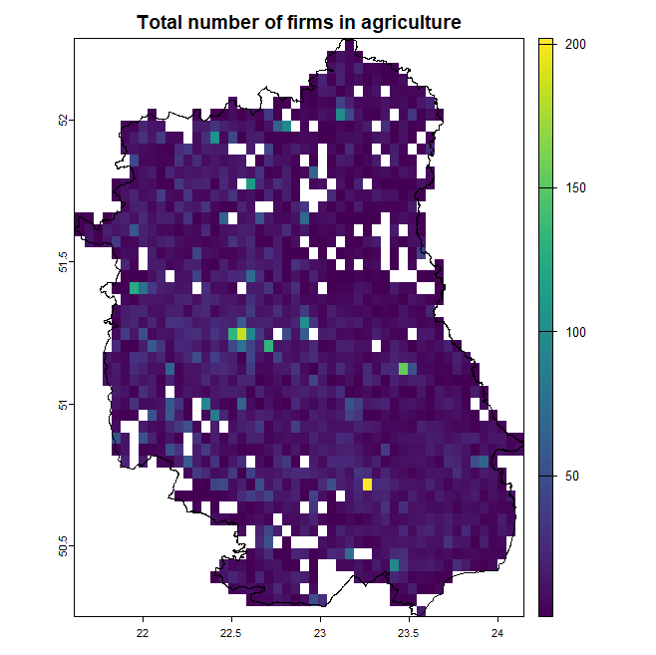

# total number of firms in service
sub<-firms[firms$SEC_agg=="serv", ]
r3<-rasterize(as.matrix(sub[,crds.xy]), r, value=sub$ones, fun=sum)
plot(r3, main="Total number of firms in service")
plot(st_geometry(region), add=TRUE)

# average profitability of firms
r4<-rasterize(as.matrix(firms[,crds.xy]), r, value=firms$roa, fun=mean)
plot(r4, main="Average profitability of firms")
plot(st_geometry(region), add=TRUE)

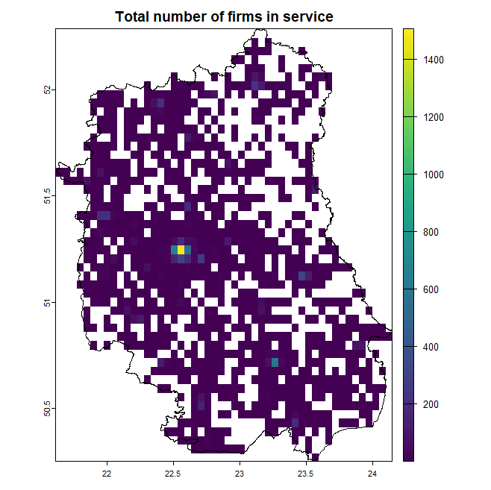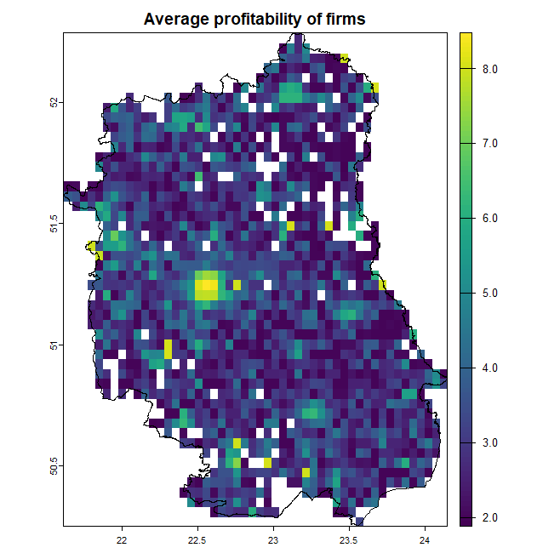

# total number of big firms
sub<-firms[firms$empl_av_size>150, ]
r5<-rasterize(as.matrix(sub[,crds.xy]), r, value=sub$ones, fun=sum)
plot(r5, main="Total number of big firms")
plot(st_geometry(region), add=TRUE)

# total number of high tech firms
sub<-firms[firms$if_high_tech==1, ]
r6<-rasterize(as.matrix(sub[,crds.xy]), r, value=sub$ones, fun=sum)
plot(r6, main="Total number of high tech firms")
plot(st_geometry(region), add=TRUE)

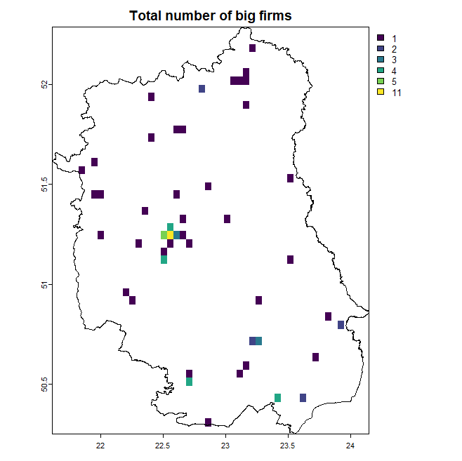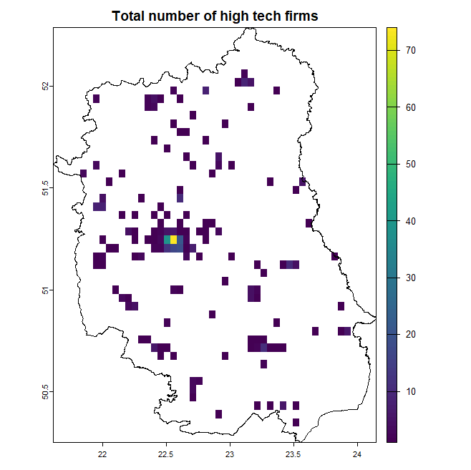

# average distance to core city
r7<-rasterize(as.matrix(firms[,crds.xy]), r, value=firms$dist.lublin, fun=mean)
plot(r7, main="Average distance to core city")
plot(st_geometry(region), add=TRUE)

# average distance to the closest city
r8<-rasterize(as.matrix(firms[,crds.xy]), r, value=firms$min.dist, fun=mean)
plot(r8, main="Average distance to the closest city")
plot(st_geometry(region), add=TRUE)

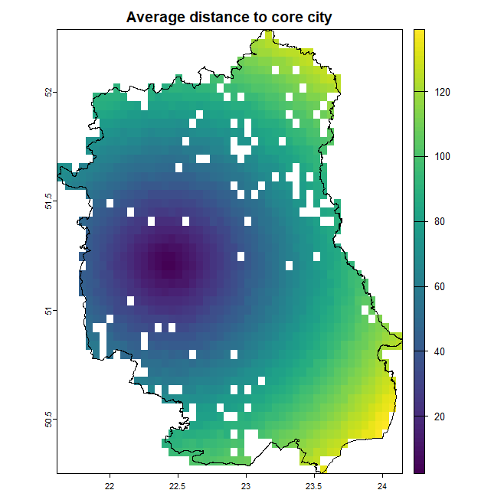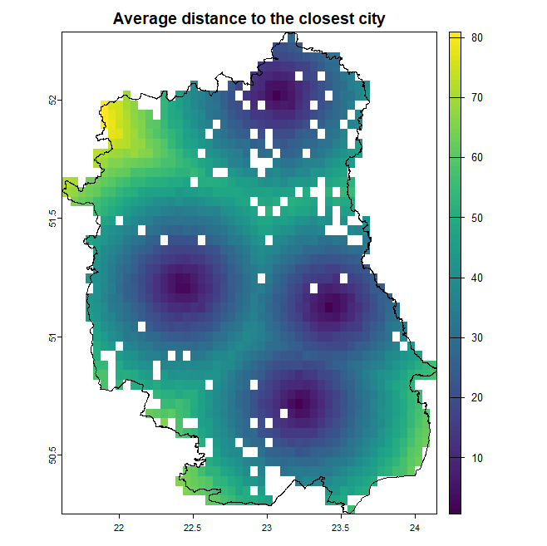

# total number of inhabitants
r9<-rasterize(as.matrix(popul[,1:2]), r, value=popul$ones, fun=sum)
plot(r9, main="Total number of inhabitants")
plot(st_geometry(region), add=TRUE)

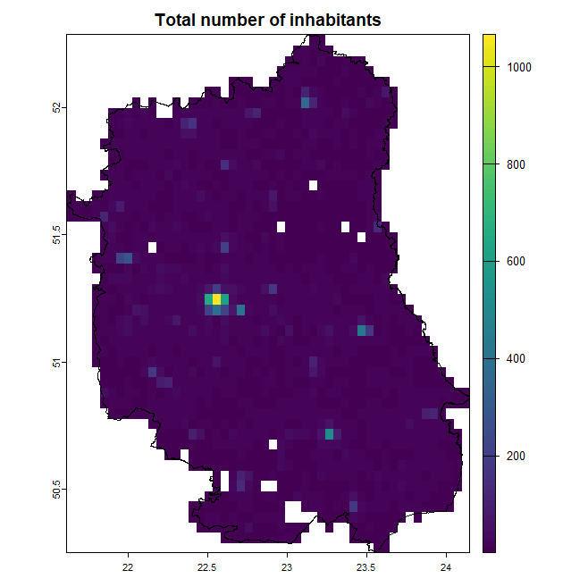

# data curation for the model
# factor variable for high-tech firms – dependent variable
r6.val<-as.vector(r6$sum)
r6.val[r6.val>=1]<-"high_tech_present"
r6.val[is.na(r6.val)==TRUE]<-"high_tech_absent"
r6.val<-as.factor(r6.val)

# merge data into single data object
rast.data<-data.frame(r6=r6.val, r1=as.vector(r1$sum), r2=as.vector(r2$sum), r3=as.vector(r3$sum), r4=as.vector(r4$mean), r5=as.vector(r5$sum), r7=as.vector(r7$mean), r8=as.vector(r8$mean), r9=as.vector(r9$sum))

head(rast.data)
r6 r1 r2 r3 r4 r5 r7 r8 r9
1 high-tech absent NA NA NA NA NA NA NA NA
2 high-tech absent NA NA NA NA NA NA NA NA
3 high-tech absent NA NA NA NA NA NA NA NA
4 high-tech absent NA NA NA NA NA NA NA NA
5 high-tech absent NA NA NA NA NA NA NA NA
6 high-tech absent NA NA NA NA NA NA NA NA

# change NA into 0
rast.data[is.na(rast.data)==TRUE]<-0
head(rast.data)
r6 r1 r2 r3 r4 r5 r7 r8 r9
1 high-tech absent 0 0 0 0 0 0 0 0
2 high-tech absent 0 0 0 0 0 0 0 0
3 high-tech absent 0 0 0 0 0 0 0 0
4 high-tech absent 0 0 0 0 0 0 0 0
5 high-tech absent 0 0 0 0 0 0 0 0
6 high-tech absent 0 0 0 0 0 0 0 0

colnames(rast.data)<-c("r6_if_hightech", "r1_tot_firms", "r2_tot_agri", "r3_tot_serv", "r4_roa", "r5_big_firms", "r7_dist_lublin", "r8_dist_min", "r9_popul")
head(rast.data)
r6_if_hightech r1_tot_firms r2_tot_agri r3_tot_serv r4_roa r5_big_firms r7_dist_lublin
1 high-tech absent 0 0 0 0 0 0
2 high-tech absent 0 0 0 0 0 0
3 high-tech absent 0 0 0 0 0 0
4 high-tech absent 0 0 0 0 0 0
5 high-tech absent 0 0 0 0 0 0
6 high-tech absent 0 0 0 0 0 0
r8_dist_min r9_popul
1 0 0
2 0 0
3 0 0
4 0 0
5 0 0
6 0 0

# 2. Data processing – calculate average in neighbouring cells
# spatial weights matrix – contiguity criterion (share common border)
library(stars)
library(spdep)

# convert raster from terra class to sf class and to sp class
r.stars<-stars:::st_as_sf.stars(stars::st_as_stars(r9), point=FALSE, merge=FALSE, connect8=TRUE, na.rm=FALSE) # class sf

# a matrix of centroids of rasters
my.xy<-st_coordinates(st_centroid(r.stars))

# spatial neighbourhood nb and listw matrix from raster in sf class
conti.nb<-poly2nb(r.stars) # with spdep::
conti.listw<-nb2listw(conti.nb, style="W")

# spatial lags of variables – average in the neighbourhoods
rast.data$r1.slag<-lag.listw(conti.listw, rast.data$r1_tot_firms)
rast.data$r2.slag<-lag.listw(conti.listw, rast.data$r2_tot_agri)
rast.data$r3.slag<-lag.listw(conti.listw, rast.data$r3_tot_serv)
rast.data$r4.slag<-lag.listw(conti.listw, rast.data$r4_roa)
rast.data$r5.slag<-lag.listw(conti.listw, rast.data$r5_big_firms)
rast.data$r7.slag<-lag.listw(conti.listw, rast.data$r7_dist_lublin)
rast.data$r8.slag<-lag.listw(conti.listw, rast.data$r8_dist_min)
rast.data$r9.slag<-lag.listw(conti.listw, rast.data$r9_popul)

rast.data$r6_dummy<-0
rast.data$r6_dummy[rast.data$r6_if_hightech=="high-tech present"]<-1
rast.data$r6.slag<-lag.listw(conti.listw, rast.data$r6_dummy)

# 3. Data processing – prepare non-empty clustered subsets

my.kmeans<-kmeans(my.xy, 3)
rast.data$cluster<-my.kmeans$cluster
r6_if_hightech r1_tot_firms r2_tot_agri r3_tot_serv r4_roa r5_big_firms r7_dist_lublin
1 high-tech absent 0 0 0 0 0 0
2 high-tech absent 0 0 0 0 0 0
3 high-tech absent 0 0 0 0 0 0
4 high-tech absent 0 0 0 0 0 0
5 high-tech absent 0 0 0 0 0 0
6 high-tech absent 0 0 0 0 0 0
r8_dist_min r9_popul r1.slag r2.slag r3.slag r4.slag r5.slag r6.slag r7.slag r8.slag r9.slag
1 0 0 0 0 0 0 0 0 0 0 0
2 0 0 0 0 0 0 0 0 0 0 0
3 0 0 0 0 0 0 0 0 0 0 0
4 0 0 0 0 0 0 0 0 0 0 0
5 0 0 0 0 0 0 0 0 0 0 0
6 0 0 0 0 0 0 0 0 0 0 0
r6_dummy cluster
1 0 1
2 0 1
3 0 1
4 0 1
5 0 1
6 0 1

plot(st_geometry(region.voi))
points(my.xy, col=rast.data$cluster, pch=21)
points(firms.sf, pch=".")

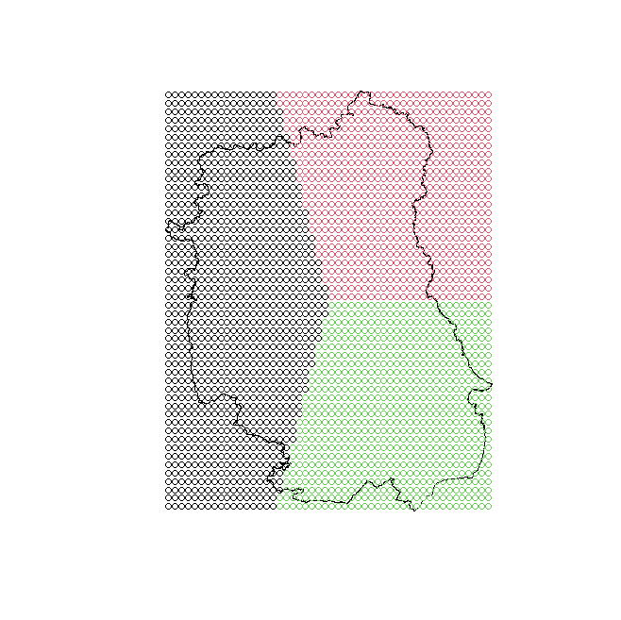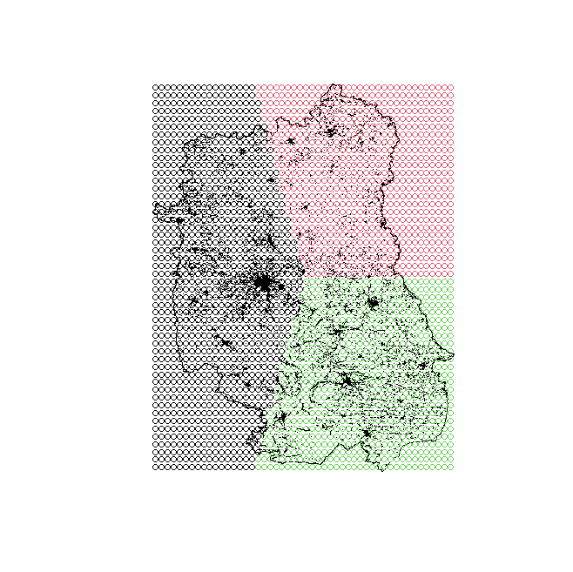

# eliminate empty lines (mostly out of the contour)
rast.data.mean<-apply(rast.data[,2:9], 1, mean)
empty<-which(rast.data.mean==0)
rast.data.fullcells<-rast.data[-empty,] # dataset with full lines
head(rast.data.fullcells)
r6_if_hightech r1_tot_firms r2_tot_agri r3_tot_serv r4_roa r5_big_firms r7_dist_lublin
31 high-tech absent 5 4 0 2.608027 0 127.1924
32 high-tech absent 0 0 0 0.000000 0 0.0000
79 high-tech absent 2 2 0 1.994211 0 119.2722
80 high-tech absent 24 11 9 4.621278 0 120.0312
81 high-tech absent 9 7 0 2.650118 0 122.8709
82 high-tech absent 2 1 1 4.936851 0 124.1882
r8_dist_min r9_popul r1.slag r2.slag r3.slag r4.slag r5.slag r6.slag r7.slag r8.slag
31 27.14922 7 7.000 3.800 2.000 2.441649 0.000 0 73.41807 13.310963
32 0.00000 1 3.200 2.400 0.200 2.038999 0.000 0 74.85031 14.651878
79 20.05592 12 8.625 5.125 2.125 1.473783 0.000 0 44.51889 7.240351
80 20.44464 19 8.875 6.250 1.125 2.201639 0.000 0 90.65433 15.807820
81 22.50431 11 14.375 8.000 3.875 2.894095 0.125 0 91.46466 16.313382
82 23.60587 5 9.375 5.625 2.250 1.929039 0.125 0 76.79739 14.065112
r9.slag r6_dummy cluster
31 7.200 0 2
32 4.800 0 2
79 6.125 0 2
80 8.000 0 2
81 11.000 0 2
82 8.375 0 2

dim(rast.data)
#[1] 2500 20
dim(rast.data.fullcells)
#[1] 1629 20

table(rast.data.fullcells$cluster)
# 1 2 3
#632 410 587

# 4. Artificial neural network model

Equation is to explain what makes that high-tech firms locate in particular place (raster cell)
‘Smaller model’ uses information from particular cell only - rule of thumb for neurons for cluster 1 is 632/(10*(8+2))=6
‘Bigger model’ uses information from particular cell and neighbouring cells (as spatial lags) - rule of thumb for neurons for cluster 1 is 632/(10*(18+2))=3

names(rast.data.fullcells)
[1] "r6_if_hightech" "r1_tot_firms" "r2_tot_agri" "r3_tot_serv" "r4_roa"
[6] "r5_big_firms" "r7_dist_lublin" "r8_dist_min" "r9_popul" "r1.slag"
[11] "r2.slag" "r3.slag" "r4.slag" "r5.slag" "r6.slag"
[16] "r7.slag" "r8.slag" "r9.slag" "r6_dummy" "cluster"

eq.smaller<-r6_if_hightech ~ r1_tot_firms + r2_tot_agri + r3_tot_serv + r4_roa +r5_big_firms +r7_dist_lublin + r8_dist_min + r9_popul

eq.bigger<-r6_if_hightech ~ r1_tot_firms + r2_tot_agri + r3_tot_serv + r4_roa +r5_big_firms +r7_dist_lublin + r8_dist_min + r9_popul + r1.slag + r2.slag + r3.slag + r4.slag + r5.slag + r6.slag + r7.slag + r8.slag + r9.slag + r6_dummy

library(caret)
library(nnet)
library(NeuralNetTools)
library(neuralnet)
# outcome variable must be a factor
rast.data.fullcells$r6_if_hightech<-factor(rast.data.fullcells$r6_if_hightech, levels=c("high_tech_absent", "high_tech_present"))

# model uses cluster=1 to train and cluster=2 to test
train_data<-rast.data.fullcells[rast.data.fullcells$cluster==1,]
test_data<-rast.data.fullcells[rast.data.fullcells$cluster==2,]

train_data<-droplevels(train_data) # drop unused levels from a ‘factor’
test_data<-droplevels(test_data) # from base::
table(train_data$r6_if_hightech)
table(test_data$r6_if_hightech)
ctrl<-trainControl(method="cv", number=5, classProbs=TRUE) # from caret::

# smaller model
model_smaller<-train(eq.smaller, data=train_data, method="nnet", trControl=ctrl, trace=FALSE)
model_smaller
pred_class<-predict(model_smaller, newdata=test_data) # predicted labels
pred_prob<-predict(model_smaller, newdata=test_data, type="prob") # pred.prob
confusionMatrix(pred_class, test_data$r6_if_hightech) # quality metrics
iii<-garson(model_smaller) # variable importance
iii@data # values sorted increasingly
iii

model.nn.smaller<-neuralnet(eq.smaller, data=train_data, hidden=c(4, 2),
linear.output=FALSE, stepmax=1e7, lifesign="full") # neuralnet::
hidden: 4, 2 thresh: 0.01 rep: 1/1 steps: 1000 min thresh: 0.0920827488674732
2000 min thresh: 0.0220074165359142
3000 min thresh: 0.0159701065197495
3458 error: 14.29816 time: 3.54 secs

plot(model.nn.smaller, rep="best")
model.nn.smaller$result.matrix

# bigger model
model_bigger<-train(eq.bigger, data=train_data, method="nnet", trControl=ctrl, trace=FALSE)
model_bigger
pred_class<-predict(model_bigger, newdata=test_data) # predicted labels
pred_prob<-predict(model_bigger, newdata=test_data, type="prob") # pred.prob
confusionMatrix(pred_class, test_data$r6_if_hightech) # quality metrics
iii<-garson(model_bigger) # variable importance
iii@data # values sorted increasingly
iii
model.nn.bigger<-neuralnet(eq.bigger, data=train_data, hidden=c(2, 1),
linear.output=FALSE, stepmax=1e7, lifesign="full") # neuralnet::

hidden: 2, 1 thresh: 0.01 rep: 1/1 steps: 1000 min thresh: 0.0248677784412471
2000 min thresh: 0.0137754329265687
2518 error: 17.49082 time: 1.49 secs

plot(model.nn.bigger, rep="best")
model.nn.bigger$result.matrix

Smaller model | Bigger model
Confusion Matrix and Statistics  Reference  Prediction high_tech_absent high_tech_present  high_tech_absent 383 27  high_tech_present 22 24  Accuracy : 0.8925  95% CI : (0.8604, 0.9194)  No Information Rate : 0.8882  P-Value [Acc > NIR] : 0.4190  Kappa : 0.4349  Mcnemar's Test P-Value : 0.5677  Sensitivity : 0.9457  Specificity : 0.4706  Pos Pred Value : 0.9341  Neg Pred Value : 0.5217  Prevalence : 0.8882  Detection Rate : 0.8399  Detection Prevalence : 0.8991  Balanced Accuracy : 0.7081  'Positive' Class : high_tech_absent | Confusion Matrix and Statistics  Reference  Prediction high_tech_absent high_tech_present  high_tech_absent 405 51  high_tech_present 0 0  Accuracy : 0.8882  95% CI : (0.8556, 0.9156)  No Information Rate : 0.8882  P-Value [Acc > NIR] : 0.5372  Kappa : 0  Mcnemar's Test P-Value : 2.534e-12  Sensitivity : 1.0000  Specificity : 0.0000  Pos Pred Value : 0.8882  Neg Pred Value : NaN  Prevalence : 0.8882  Detection Rate : 0.8882  Detection Prevalence : 1.0000  Balanced Accuracy : 0.5000  'Positive' Class : high_tech_absent
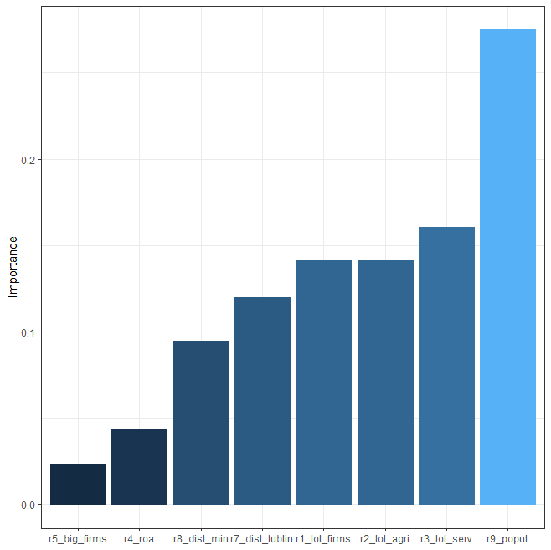 | 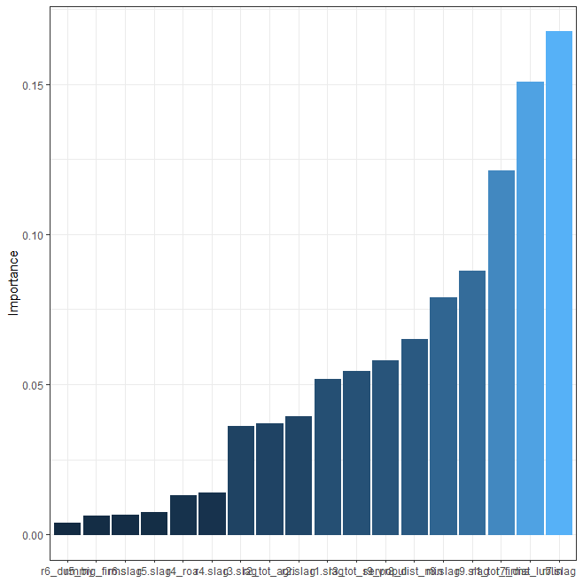
rel_imp x_names  5 0.02330070 r5_big_firms  4 0.04338559 r4_roa  7 0.09473019 r8_dist_min  6 0.11967567 r7_dist_lublin  1 0.14168996 r1_tot_firms  2 0.14173244 r2_tot_agri  3 0.16061778 r3_tot_serv  8 0.27486767 r9_popul | rel_imp x_names  18 0.003954800 r6_dummy  5 0.006347571 r5_big_firms  14 0.006720190 r6.slag  13 0.007576136 r5.slag  4 0.013173598 r4_roa  12 0.013834883 r4.slag  11 0.036070764 r3.slag  2 0.036976542 r2_tot_agri  10 0.039421054 r2.slag  9 0.051908498 r1.slag  3 0.054459978 r3_tot_serv  8 0.058026289 r9_popul  7 0.065088320 r8_dist_min  16 0.079065949 r8.slag  17 0.087698288 r9.slag  1 0.121354652 r1_tot_firms  6 0.150745256 r7_dist_lublin  15 0.167577233 r7.slag
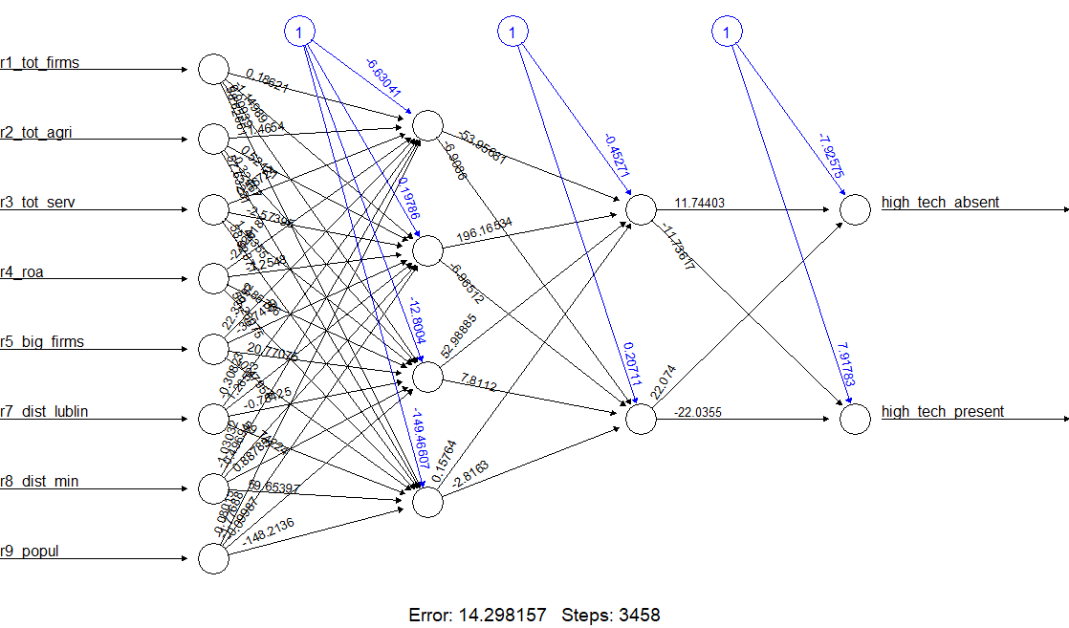 | 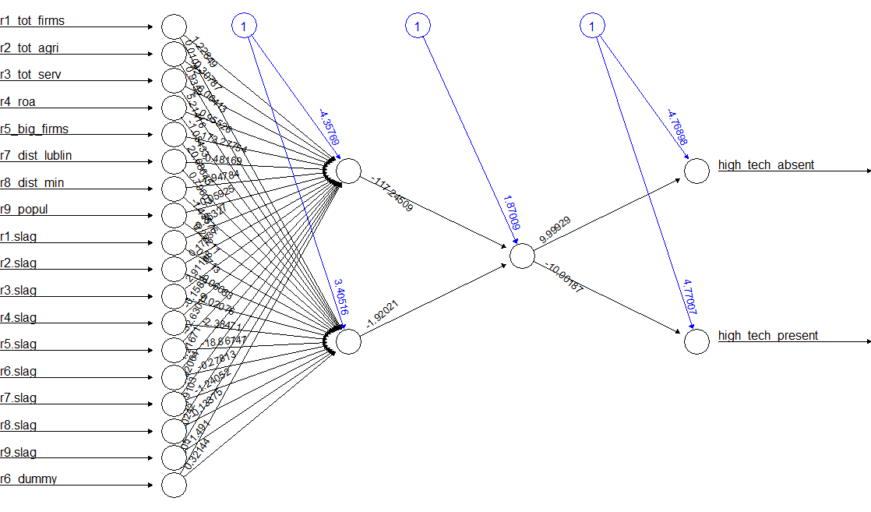
error 1.429816e+01  reached.threshold 8.965827e-03  steps 3.458000e+03  Intercept.to.1layhid1 -6.630410e+00  r1_tot_firms.to.1layhid1 1.862084e-01  r2_tot_agri.to.1layhid1 1.465401e+00 | error 1.749082e+01  reached.threshold 9.502755e-03  steps 2.518000e+03  Intercept.to.1layhid1 -4.357689e+00  r1_tot_firms.to.1layhid1 1.228488e+00  r2_tot_agri.to.1layhid1 3.078711e-01
Neural Network  679 samples  8 predictor  2 classes: 'high_tech_absent', 'high_tech_present'  No pre-processing  Resampling: Cross-Validated (5 fold)  Summary of sample sizes: 543, 543, 543, 543, 544  Resampling results across tuning parameters:  size decay Accuracy Kappa  1 0e+00 0.9455120 0.0000000  1 1e-04 0.9484532 0.3076253  1 1e-01 0.9528649 0.2159990  3 0e+00 0.9499237 0.1174507  3 1e-04 0.9543682 0.3932809  3 1e-01 0.9573094 0.5106831  5 0e+00 0.9484858 0.3591123  5 1e-04 0.9646514 0.5449561  5 1e-01 0.9572985 0.5127963  Accuracy was used to select the optimal model using the largest value.  The final values used for the model were size = 5 and decay = 1e-04. | Neural Network  679 samples  18 predictor  2 classes: 'high_tech_absent', 'high_tech_present'  No pre-processing  Resampling: Cross-Validated (5 fold)  Summary of sample sizes: 543, 543, 544, 544, 542  Resampling results across tuning parameters:  size decay Accuracy Kappa  1 0e+00 0.9425913 0.09742094  1 1e-04 0.9469815 0.06854010  1 1e-01 0.9484524 0.36815161  3 0e+00 0.9528637 0.32608232  3 1e-04 0.9617093 0.40028228  3 1e-01 0.9602278 0.46388890  5 0e+00 0.9484412 0.42358062  5 1e-04 0.9558159 0.37280184  5 1e-01 0.9602062 0.51358511  Accuracy was used to select the optimal model using the largest value.  The final values used for the model were size = 3 and decay = 1e-04.

# 5. Random Forest model

library(randomForest)

y<-train_data[, "r6_if_hightech"] # y variable – continuous
x<-train_data[,c("r1_tot_firms", "r2_tot_agri", "r3_tot_serv", "r4_roa", "r5_big_firms", "r7_dist_lublin", "r8_dist_min", "r9_popul", "r6_dummy", "r1.slag", "r2.slag", "r3.slag", "r4.slag", "r5.slag", "r7.slag", "r8.slag", "r9.slag", "r6.slag")] # x variables

rf.global<-randomForest(x, y, importance=TRUE)
rf.global

Call:
randomForest(x = x, y = y, importance = TRUE)
Type of random forest: classification
Number of trees: 500
No. of variables tried at each split: 4

OOB estimate of error rate: 3.98%
Confusion matrix:
high_tech_absent high_tech_present class.error
high_tech_absent 638 4 0.00623053
high_tech_present 23 14 0.62162162

varImpPlot(rf.global) # variable importance

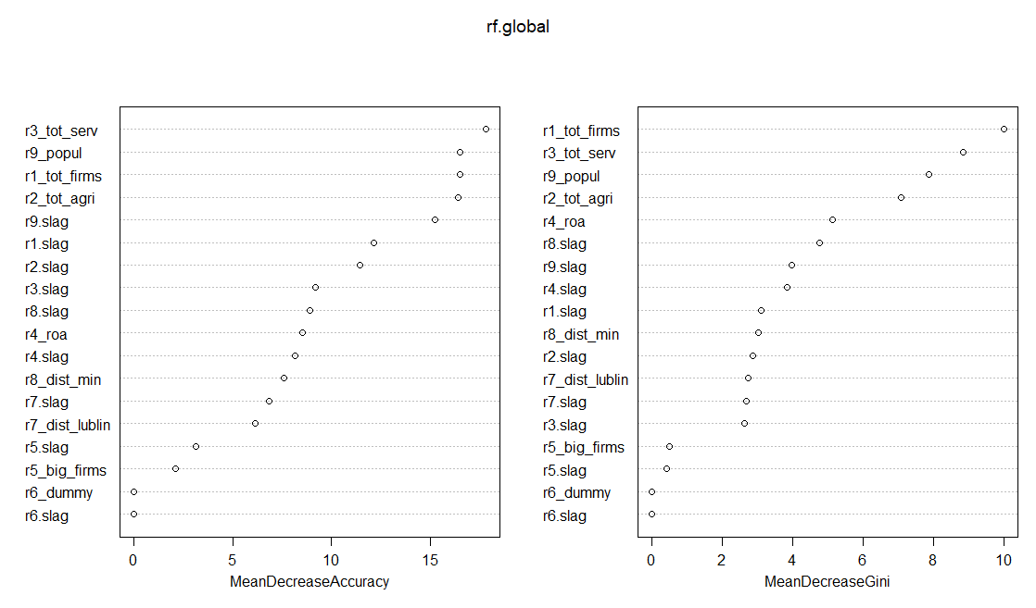

partialPlot(rf.global, x, r3_tot_serv, xlim=c(0,120)) # partial plots
partialPlot(rf.global, x, r9_popul, xlim=c(0,120)) # partial plots

